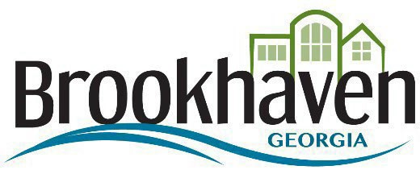

February 24, 2024

SENT VIA ELECTRONIC

C.W Matthews
1600 Kenview Dr
Marietta Georgia 30060
Phone: 4042773637
Mikek@cwmatthews.com

RE: 24-002: 2024/2025/2026 Capital Pavement – Intent to Award

In compliance with solicitation conditions, as described in the above-referenced Invitation to Bid, this letter shall serve as an official notification of the City of Brookhaven's intent to enter into a contract with your company. The contract, for which you are being considered for award, is estimated to be in the amount of
$18,026,311.66

In further compliance with the City of Brookhaven solicitation conditions, you may now proceed with acquiring and providing (within three (3) days) the following documents as outlined in the solicitation conditions:

- Original Certificate of Insurance as indicated below, executed by an authorized representative of the insurer:
  - Workers ' Compensation
  - Comprehensive General Liability
  - Automotive Liability (Owned, hired, and non-owned)
- W9

Thank you for your interest in doing business with the City of Brookhaven.

Sincerely,
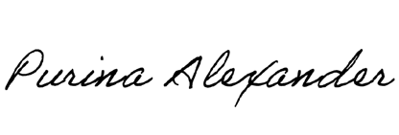
Purina Alexander

Purchasing Department · 4362 Peachtree Road NE, Brookhaven, Georgia 30319 · www.brookhavenga.gov

